Ethernet

1. One of the most widely used Wired LAN technologies.
2. Operates in the data link layer and the physical layer.
3. Family of networking technologies that are defined in the IEEE 802.2 and 802.3 standards.
4. Supports data bandwidths of 10, 100, 1000, 10000, 40000 and 100000 Mbps(100 Gbps)
5. Ethernet Standards:
   1. Define Layer 2 protocols and Layer 1 technologies.
   2. Two separate sublayers of the data link layer to operate - Logical Link control (LLC) and the MAC sublayers.
6. 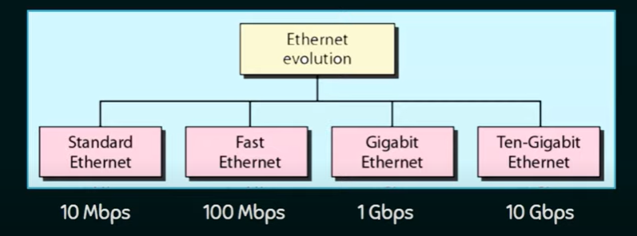
7. 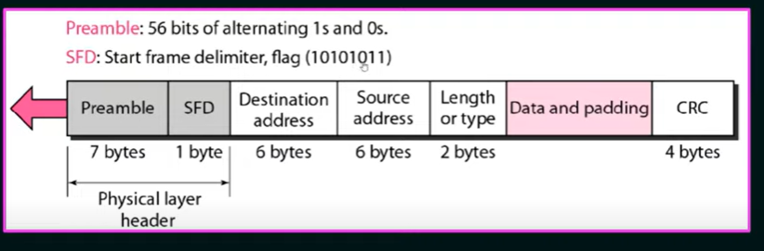
8. 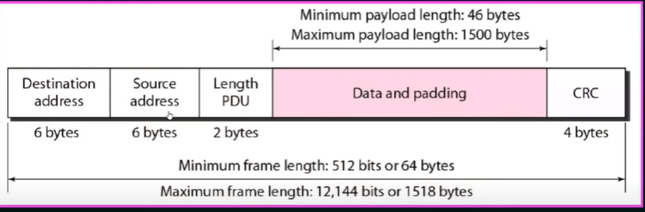

Ethernet address

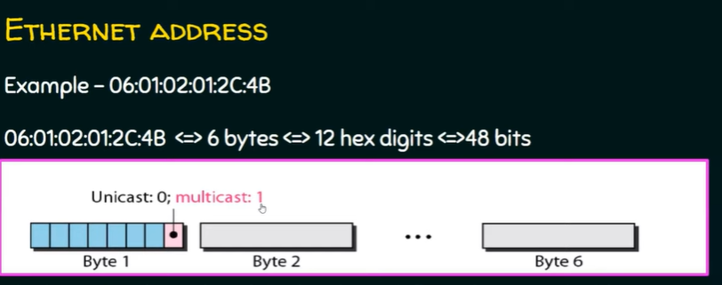

1. The least significant bit of the first byte defines the type of address.
2. If the bit is 0, the address is unicast; otherwise it is multicast
3. If all bits are 1, then it is broadcast address.